**Setup the Bolt Python Library**

As you have already learned about Python basics in the previous topics, Now in this section we will learn to build the IoT product with Bolt Python library. The Bolt Python library makes it easy to interact with the Bolt cloud API from your Python application.

You can control or fetch the data from Bolt cloud to your server(In this workshop Ubuntu from DigitalOcean or from VirtualMachine is your server.), as you have learned about control API and controlling LED in Module-1, but in that case every time you had to go to [https://cloud.boltiot.com](https://cloud.boltiot.com/) if you wanted to control your Bolt. What if you want to build something of your own on your own server? Then Bolt Python library will help you in building the IoT product.

Before you proceed to this step, first ssh(login) to your Ubuntu server and follow the below steps to use Bolt Python library in your code.

**Step 1:** Update the packages on Ubuntu

Execute the command below so that the packages on Ubuntu are updated to the latest version. If you skip this step, you may encounter an error while installing the Boltiot package.

sudo apt-get -y update

**Step 2:** Install python3 pip3

pip3 is a package manager for python3

azto install and manage packages and python libraries. It is system independent.

Install pip3 using the following command,

sudo apt install python3-pip

**Step 3:** Installing boltiot library using pip

Now we will install the boltiot python library on your Ubuntu server.

Type the below command in terminal to install boltiot python library.

sudo pip3 install boltiot

Now we are done with boltiot python library installation. In the next section, we will learn how to use the Bolt python library to check the device status and switch off the device.

Troubleshooting

**Note -** If you are getting **Python locale error: unsupported locale setting** then run the following commands

export LC_ALL="en_US.UTF-8"

export LC_CTYPE="en_US.UTF-8"

sudo dpkg-reconfigure locales

After typing the above command, a pop up will open. Select **All locales** and click enter.

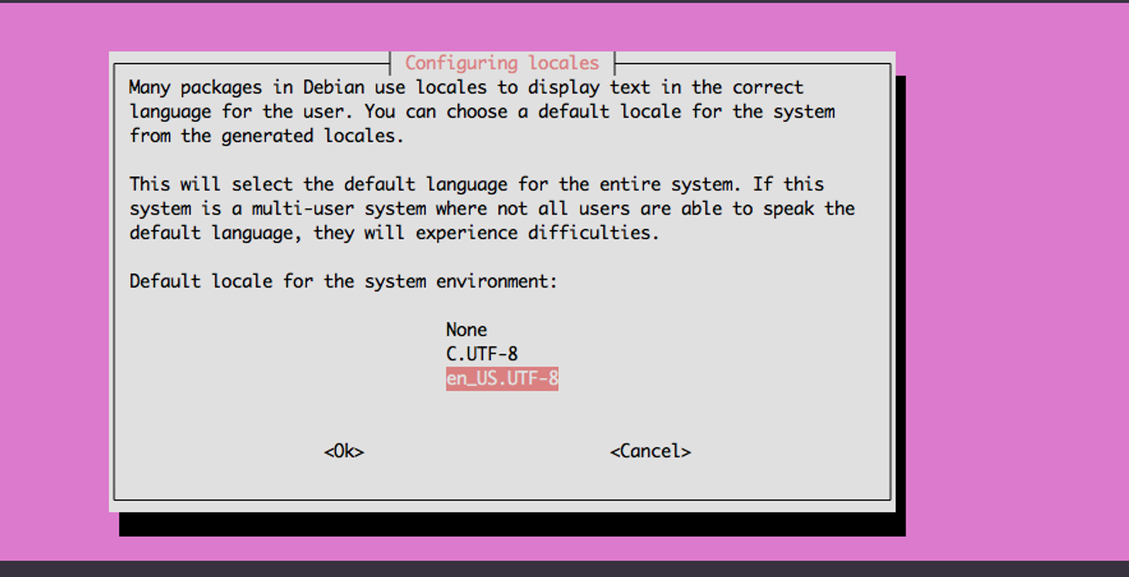

And then another pop will open. Select **en_US.UTF-8** and then press enter.

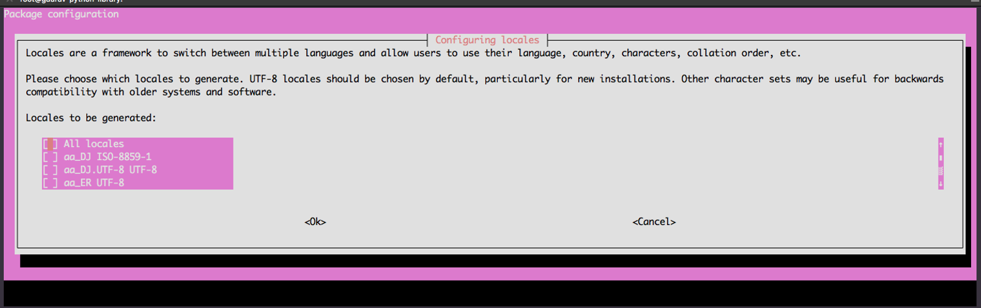

Note: The above settings will stop working after closing the current session.